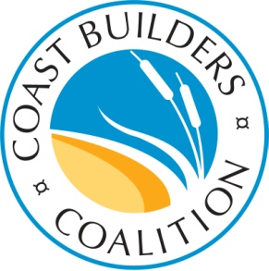

Full Member Benefits - $5,000 per year
GOVERNMENT LIAISON/ADVOCACY – Opportunity to sit on board of directors and set direction and policy of group
ACCESS – Invitation to all CBC meetings and events including 8-10 meetings annually with top local, state and federal officials involved in coastal issues
INTELLIGENCE – Monthly newsletter along with email updates on hot topics
COLLABORATION – Opportunity to be an industry rep on behalf of the Coast Builders Coalition at various events and meetings with NGOs, academics and government officials
BUSINESS DEVELOPMENT – Networking at all of the Coast Builders Coalition’s events; recognition in CBC publications

Associate Member Benefits - $1,000 per year
ACCESS/BUSINESS DEVELOPMENT – Invitation to annual meeting and CBC legislative day; recognition as associate member in CBC publications
INTELLIGENCE – Receipt of monthly e-blasts

